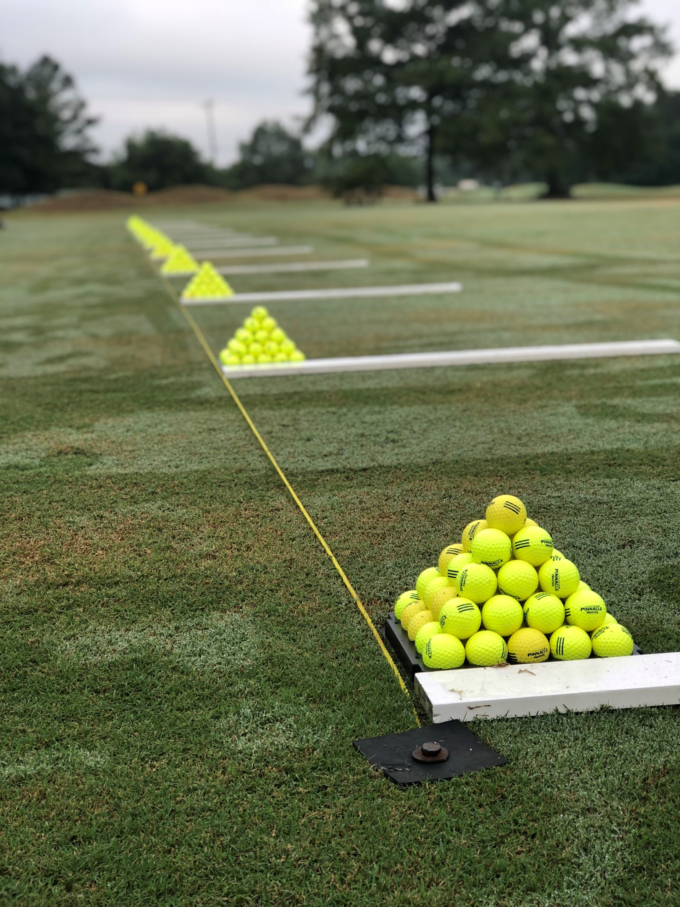

**ADULT**

**Golf Instruction and Clinics**

**2024**

**Instruction**

The Mississippi State University Golf Course PGA Professional Staff is here to help you with every aspect of your game! Whether you need a quick tune-up or want to develop a long-term game improvement program, our experienced and knowledgeable staff is ready to help. We offer a variety of programs and pricing to meet the needs of every student while being aware of time and budget.  
  
If you have any questions or would like more information, please contact the following teachers:

Head Golf Professional

Tim Basel, PGA at [tbasel@business.msstate.edu](mailto:tbasel@business.msstate.edu)

662.325.3028.

Assistant Golf Professional

Nate Kitson, PGA at [nkitson@business.msstate.edu](mailto:nkitson@business.msstate.edu)

662.325.3028

Teaching Professional

Erika Scott, PGA at [escott@business.msstate.edu](mailto:escott@business.msstate.edu)



Have you heard of PGA.coach? All signups and communication will be done through the coach app as you will deal directly with the PGA instructor for the specific offering. Tim, Nate, and Erika provide over 50 years of both tournament and teaching experience to bring you quality instruction at affordable pricing in a group setting. Grab a friend and sign up for a clinic or sign up individually.

Go to Instagram @hailstategc and click on the linktree in our bio to see offerings currently available.

These will change quite a bit so check back often!!

|  |
| --- |
| **MSU Golf Course Professional Staff Contact Information**  **14279 MS HWY 182**  **Starkville, MS 39759**  **662.325.3028 golf.msstate.edu** |
| Image result for certified pga professional logo  **Tim Basel, PGA**  **Head Golf Professional**  [**tbasel@business.msstate.edu**](mailto:tbasel@business.msstate.edu) |
| PGA - Nextgengolf  **Nate Kitson, PGA**  **Assistant Golf Professional**  [**nkitson@business.msstate.edu**](mailto:nkitson@business.msstate.edu) |
| PGA - Nextgengolf  **Erika Scott, PGA**  **Golf Instructor**  [**escott@business.msstate.edu**](mailto:escott@business.msstate.edu) |